use [Pizza-DB]

select*from pizza_sales

-- KPI’s

--1. Total Revenue:

select sum(total_price)as Total_Revenue

from pizza_sales

--2. Average Order Value

select sum(total_price)/count(distinct(order_id)) as Avg_order_value

from pizza_sales

--3. Total Pizzas Sold

select sum(quantity) as Total_pizza_sold

from pizza_sales

--4. Total Orders

select count(distinct(order_id))as Total_orders

from pizza_sales

--5. Average Pizzas Per Order

select cast(sum(quantity)/count(distinct(order_id))as decimal(10,2)) as Avg_pizza_per_order

from pizza_sales

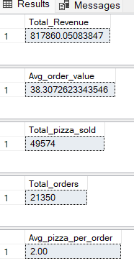

-----------------------------------------------

--Charts:

--Daily Trend

select datename(dw,order_date)as order_day, count(distinct(order_id))as Total_order

from pizza_sales

group by datename(dw,order_date)

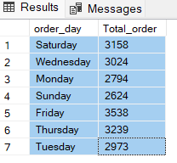

--Hourly Trend

select DATEPART(hour,order_time)as order_hours,count(distinct(order_id))as Total_orders

from pizza_sales

group by DATEPART(hour,order_time)

order by Total_orders desc

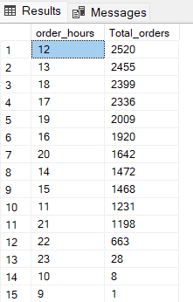

--percentage os sales by pizza category

select pizza_category,cast(sum(total_price) as decimal(10,2)) as Total_sales,

cast(sum(total_price)*100/(select sum(total_price) from pizza_sales where month(order_date)=1) as decimal(10,2))as Percentage_of_sales

from pizza_sales

where month(order_date)=1

group by pizza_category

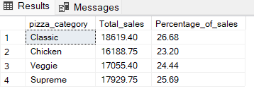

--percentage of sales by pizza size

select pizza_size,cast(sum(total_price) as decimal(10,2)) as Total_sales,

cast(sum(total_price)*100/(select sum(total_price) from pizza_sales where datepart(quarter,order_date)=1) as decimal(10,2))as Percentage_of_sales

from pizza_sales

where datepart(quarter,order_date)=1

group by pizza_size

order by Percentage_of_sales desc

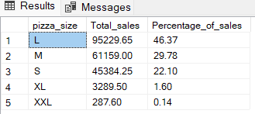

--Total Pizza Sold By Pizza Category

select pizza_category, sum(quantity) as Total_pizza_sold

from pizza_sales

group by pizza_category

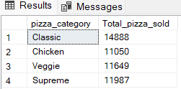

--Top 5 Best Sellers by Total Pizzas Sold

select top 5 pizza_name,sum(quantity)as total_pizza_sold

from pizza_sales

group by pizza_name

order by total_pizza_sold desc

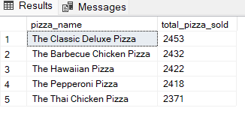

--Bottom 5 Best Sellers by Total Pizzas Sold

select top 5 pizza_name,sum(quantity)as total_pizza_sold

from pizza_sales

where month(order_date)=1

group by pizza_name

order by total_pizza_sold

